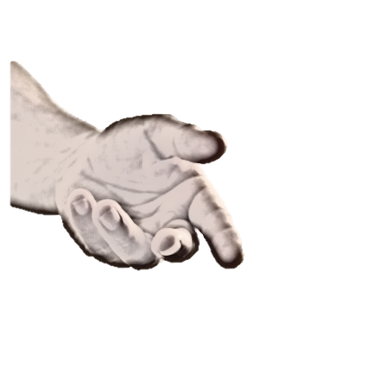

*The Red Cross Club is for high school students who are committed to making their schools, their communities and the world a better place. It’s intended for you if you’re willing to help a friend or stranger in trouble. It’s for you if you believe you can help improve and save lives.*

**Last Name:** __________________________ **First Name:** _________________________________

**Date of Birth (mm/dd/yy):** __________________________ **Email:** _________________________

**Home Number:** __________________________ **Mobile Number:** __________________________

**Parent/ Guardian Name:** ___________________________________________________________

**Home Number:** __________________________ **Mobile Number:** __________________________

**Emergency Number:** __________________________**Email:** ______________________________

**\*Username:** _____________________________ **Password:** _______________________________

**\*For website purposes. Username not guaranteed**

**Give a few sentences about yourself (this is can include but not limited to hobbies and awards):**

________________________________________________________________________________________________________________________________________________________________________________________________________________________________________________________________________________________________________________________________________________________________________________________________________________________________________________________________________________________________________________________________________________________________________________________________________________________________________________________________________________________________________________________________________________________.

***Please include a copy of the your most recent report card or school transcript.***

The Red Cross Club

Student Application